**EPICS REPORT**

on

**STUDY ON THE EFFECTIVENESS OF NOISE BARRIER**

A project report was submitted to

**VELAGAPUDI RAMAKRISHNA**

**SIDDHARTHA ENGINEERING COLLEGE**

In partial fulfillment of the requirements for the award of the Degree of

**BACHELOR OF TECHNOLOGY**

**in**

**CIVIL ENGINEERING**

by

PITTU YAMINI SINDHU (198W1A0143)

KOLUSU LAKSHMI MANASA (198W1A0119)

SHAIK SHARMILA BEGAM (198W1A0147)

BHASKAR SAI CHAKRAVARTULA (198W1A0105)

Under the guidance of

**Dr.Chava Srinivas**

**HOD**

**CIVIL ENGINEERING DEPT.**



**DEPARTMENT OF CIVIL ENGINEERING**

**V.R. SIDDHARTHA ENGINEERING COLLEGE**

**(AUTONOMOUS)**

**VIJAYAWADA-520007**

**ABSTRACT**

Traffic noise has been implicated in a variety of health issues in areas where there is a high density of traffic operations. Significant noise pollution has come from the expansion of urban traffic infrastructure.Noise barriers are solid obstructions built between the highway and the homes along a highway. A noise barrier is an external structure designed to protect the residents of sensitive land use areas from noise pollution.This investigation is to study the effectiveness of noise barriers in reducing noise pollution from vehicular traffic to the residential/commercial areas adjacent to the highway.

**INTRODUCTION:**

Noise barriers are widely considered to be an effective method of reducing noise propagation. With ever-increasing studies in the science of noise barriers, noise barriers have slowly gained favour as a means of noise mitigation. Despite their high expense, noise barriers are often employed to limit noise propagation along roadways and railway lines

Many countries around the world have cited traffic noise as a serious nuisance. In practically all types of land use zones, including residential, commercial, heavy traffic, and even quiet zones, noise levels steadily increase and exceed the authorized thresholds. Among these, operational noise from transportation systems accounts for over 70% of total environmental noise. Traffic noise is linked to a variety of health issues, including hearing loss, psychological strain, mental weariness, annoyance, headache, hypertension, heart damage, and a variety of other physical-biological abnormalities, such as changes in digestion, metabolism, and blood circulation. Noise levels over 130 dB (A) can be fatal.

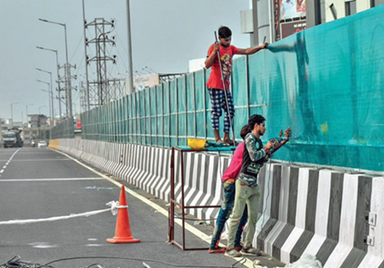

**Figure 1. Benz circle flyover-**

Total distance: 2.47km

Barriers are arranged on both sides of the flyover for an improved driving experience with less noise.

UT353 is a mini digital sound meter that is used for noise detection in decibels.

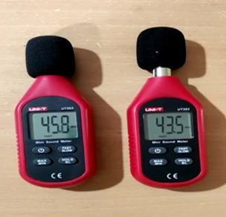

**Figure 2. Mini Digital Sound meter**

**AIM AND OBJECTIVES:**

To study the noise levels at a busy intersection, Benz circle flyover, and analysis of reduction in traffic noise ranges. The motive of the sound barriers on the edges of the highways is to prevent noise from vehicular traffic and prevent disturbances.

**LITERATURE REVIEW:**

Here are some case studies which we have gone through during our literature study.

1. In this paper noise levels on the flyover in front of Engineering College (IET Lucknow UP India) have been taken for study and a noise barrier for this location has been designed for predicted noise levels worked out using modified FHWA (Federal Highway Administration) model. This model makes use of traffic data like volume, speed composition, slope, ground cover, etc.

2.Construction of a flyover is often coupled with major changes in the environment. Many people in Delhi are exposed to high levels of traffic noise above the planning standards given by the Central Pollution Control Board. No Traffic Engineering improvement of a highway project is without both gains and losses. There is excessive traffic in Delhi and there is also limited scope to adopt traffic management solutions. So, the most effective reduction of traffic noise disturbances in urbanized areas was obtained by implementing noise barriers or enclosures.

3. The study investigates the effectiveness of an existing noise wall barrier installed in a school for shielding noise from heavy traffic in Malaysia. In Malaysia studies in school, areas have been conducted since the 1980s covering west Malaysia even before the establishment of noise regulation. These include noise levels conducted in school at three schools in Klang Valley in 1985. All these selected schools exceeded the 55dBrecommendation by the WHO for outdoor school areas that may affect teachers’ and students’ performance. It was found that the barrier efficiently achieved insertion loss of 5 dB and above.

4. Egypt’s noise levels exceed acceptable thresholds due to the high population and lack of mandatory sound regulations. According to noise measurements done by “The National Network for Noise Level Measurement in Greater Cairo,” most of the areas had shown that noise levels exceeded the standard permissible level. Noise levels reached up to 75-85dBwhich is considered unacceptable as noise levels should not exceed 65 dB during daytime and 55 dB duringnight-time. This research revealed that the fence acts as a good noise barrier and that the combined configuration of the fence resulted in the attenuation of noise to acceptable levels.

5. To improve the sound environment along a popular esplanade in Lyon, France, a 1 m high vegetated noise barrier was erected to protect against noise from an adjacent road. The effect of the barrier was evaluated by acoustic measurements conducted before and after the barrier was erected. The barrier reduced the sound pressure level from about 67 to 62dB.The result showed that the barrier reduced road-traffic noise annoyance, and increased the overall quality of the sound environment by making it slightly calmer and slightly more pleasant.

**PROBLEM STATEMENT:**

With the increase in traffic and proximity of flyovers to the buildings, citizens have been demanding the installation of sound barriers to reduce noise levels. They have also complained of intrusion into their privacy. Noise barriers block the direct path of sound waves from the highway to homes and businesses along the highway. So, this project focuses on the study of the effectiveness of noise barriers.

**METHODOLOGY:**

1. Noise standards and selection of sites:

Noise levels of various zones are decided by the concerned administration governing that particular area. As per Central Pollution Control Board (CPCB), the noise levels should not exceed 55dB in the surroundings of a residential building.

2. Assessing the effectiveness of the barriers:

Noise levels at the location were predicted based on the presence and absence of a noise barrier on the same flyover. This aids in determining the degree of noise reduction provided by the barrier.

3. Noise barrier design:

If the proposed noise barriers do not achieve the desired noise reduction, noise reduction can potentially be achieved by altering existing barriers to add extra height to reach the required levels.

4. Prediction of traffic noise:

Traffic volume counts and corresponding spot speeds were obtained for nine hours in a day. Noise levels were also recorded every fifteen seconds for a total of fifteen minutes. Noise levels were projected by feeding the above-mentioned inputs into FHWA models. After that, a comparison is done between the observed and expected noise levels to determine the range of noise levels.

5. Noise Reduction Barrier:

Solid obstructions constructed between the highway and the residences along a highway serve as noise barriers. Noise barriers do not exclude all noise; rather, they reduce noise levels to a specific level. Noise barriers reduce noise levels by 5 to 10 dB on average.

**Trail run on NH-65 without noise barrier:**

The trail run was made for a period of 1hour nearer to college on National Highway number 65 and 30m away from NH65 for every 15 minutes we have taken maximum and minimum readings on 14th march and these are the results.

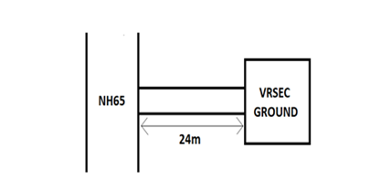

We take the distance of 24m from NH65 because the distance between the flyover and the S&H block is 24m and we want to study how the students are affected due to the vehicular traffic on the flyover



**Figure 3. At 24m from NH65**

AT 24M FROM NH 65:

| TIME (PM) | MINIMUM (dB) | MAXIMUM (dB) |
| --- | --- | --- |
| 2:35 – 2:50 | 56.4 | 57.5 |
| 2:50 – 3:05 | 55.6 | 56.6 |
| 3:05 – 3:20 | 57.6 | 59.5 |
| 3:20 – 3:35 | 56.0 | 60.4 |

**Table 1**

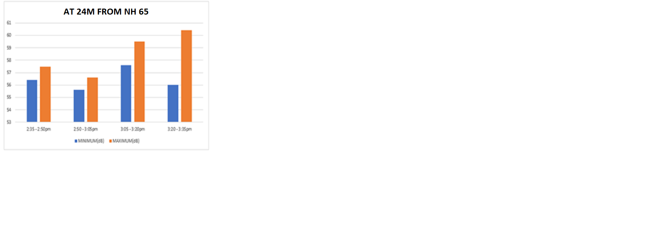

**Graph 1**



**Figure 4. On NH65**

ON NH65:

| TIME  (PM) | MINIMUM (dB) | MAXIMUM (dB) |
| --- | --- | --- |
| 2:35 – 2:50 | 75.0 | 89.6 |
| 2:50 – 3:05 | 70.0 | 80.0 |
| 3:05 – 3:20 | 67.4 | 75.6 |
| 3:20 – 3:35 | 69.6 | 90.0 |

**Table 2**

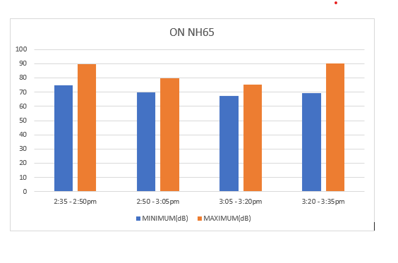

**Graph 2**

Maximum and Minimum values at 24m away from NH65 and on NH65:

| LOCATION | MINIMUM (dB) | MAXIMUM (dB) |
| --- | --- | --- |
| At 24m from NH65 | 56.4 | 60.4 |
| On NH65 | 67.4 | 90.0 |

**Table 3**

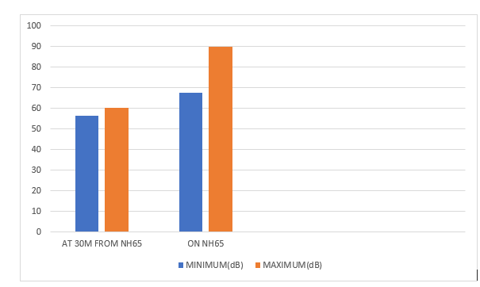

**Graph 3**

Differences in the variation of noise reduction:

Minimum: 11dB

Maximum:29.6dB

A final study was taken up on NH 65 in twoselected locations one with a noise barrier and one without a noise barrier:

| **Vehicle category** | **Direction 1 (with noise barrier)** | | **Direction 2 (without noise barrier)** | |
| --- | --- | --- | --- | --- |
|  | **Number** | **PCU** | **Number** | **PCU** |
| Cars/Jeeps | 1234 | 1234 | 2111 | 2111 |
| Vans/Stn. Wagon | 244 | 244 | 380 | 380 |
| Buses | 34 | 129 | 159 | 477 |
| Trucks | 441 | 1323 | 634 | 1902 |
| Multi-axle Trucks | 95 | 285 | 185 | 555 |
| Truck Trailers | 62 | 186 | 186 | 558 |
| Three Wheelers | 184 | 346 | 206 | 388 |
| Motor Cycles & Scooters | 1346 | 673 | 1943 | 972 |
| Tractors | 24 | 72 | 35 | 105 |
| HCM& EME | 47 | 141 | 62 | 186 |
| Cycles | 11 | 6 | 9 | 5 |
| Pedal Rickshaws | **----** | **----** | **----** | **-----** |
| **Total vehicles** | **3722** | | **5910** | |
| **Total PCU** | **4693** | | **7639** | |

**Table 4: Summary of traffic volume in terms of number and PCU values**

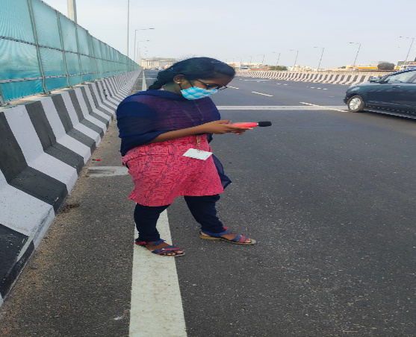



**Figure 5. On flyover Figure 6. On flyover**

**EFFECTIVENESS OF NOISE BARRIER:**

ON BENZ FLYOVER**:**

| Time (for every 15 min) | Maximum(dB) | Minimum(dB) | Avg(dB) |
| --- | --- | --- | --- |
| 10:30-10:45 (AM) | 89.8 | 69.6 | 79.7 |
| 10:45-11:00 | 91.2 | 71.5 | 81.35 |
| 11:00-11:15 | 94.0 | 77.9 | 85.95 |
| 11:15-11:30 | 85.2 | 79.0 | 82.1 |
| 2:00-2:15 (PM) | 85.5 | 65.4 | 75.45 |
| 2:15-2:30 | 89.2 | 68.2 | 78.7 |
| 2:30-2:45 | 86.3 | 64.4 | 75.35 |
| 2:45-3:00 | 89.0 | 75.2 | 82.1 |
| 4:00-4:15 | 90.0 | 75.5 | 82.75 |
| 4:15-4:30 | 89.2 | 68.3 | 78.75 |
| 4:30-4:45 | 87.4 | 69.3 | 78.35 |
| 4:45-5:00 | 91.1 | 73.2 | 82.15 |
| 6:00-6:15 | 88.2 | 76.0 | 82.1 |
| 6:15-6:30 | 89.0 | 71.2 | 80.1 |
| 6:30-6:45 | 87.3 | 71.0 | 79.15 |
| 6:45-7:00 | 94.0 | 75.2 | 84.6 |

**Table 5**

24M AWAY FROM FLYOVER:

| Time (for every 15 min) | Maximum(dB) | Minimum(dB) | Avg(dB) |
| --- | --- | --- | --- |
| 10:30-10:45 (AM) | 75.0 | 63.2 | 69.1 |
| 10:45-11:00 | 65.5 | 57.9 | 61.7 |
| 11:00-11:15 | 79.9 | 62.1 | 71.0 |
| 11:15-11:30 | 65.6 | 60.5 | 63.05 |
| 2:00-2:15 (PM) | 66.1 | 51.8 | 58.95 |
| 2:15-2:30 | 69.9 | 50.7 | 60.3 |
| 2:30-2:45 | 67.3 | 52.8 | 60.05 |
| 2:45-3:00 | 69.3 | 52.3 | 60.8 |
| 4:00-4:15 | 67.8 | 53.8 | 60.7 |
| 4:15-4:30 | 60.4 | 55.2 | 57.8 |
| 4:30-4:45 | 62.6 | 53.5 | 58.06 |
| 4:45-5:00 | 63.5 | 57.2 | 60.35 |
| 6:00-6:15 | 67.5 | 56.9 | 52.2 |
| 6:15-6:30 | 69.4 | 59.4 | 54.4 |
| 6:30-6:45 | 66.5 | 56.1 | 61.3 |
| 6:45-7:00 | 64.1 | 57.6 | 60.85 |

**Table 6**

ON BENZ FLYOVER WITHOUT NOISE BARRIER:

| Time (for every 15 min) | Maximum(dB) | Minimum(dB) | Avg(dB) |
| --- | --- | --- | --- |
| 10:30-10:45 (AM) | 100.0 | 69.1 | 84.55 |
| 10:45-11:00 | 96.5 | 74.3 | 85.4 |
| 11:00-11:15 | 104.6 | 69.8 | 87.2 |
| 11:15-11:30 | 95.4 | 62.4 | 78.9 |
| 2:00-2:15 (PM) | 74.7 | 72.1 | 73.4 |
| 2:15-2:30 | 84.9 | 76.1 | 80.5 |
| 2:30-2:45 | 83.2 | 78.2 | 80.7 |
| 2:45-3:00 | 81.2 | 73.9 | 77.5 |
| 4:00-4:15 | 99.2 | 72.4 | 85.8 |
| 4:15-4:30 | 105.0 | 73.8 | 89.4 |
| 4:30-4:45 | 104.5 | 73.1 | 88.4 |
| 4:45-5:00 | 91.7 | 73.4 | 82.5 |
| 6:00-6:15 | 100.2 | 74.9 | 87.55 |
| 6:30-6:45 | 96.4 | 70.0 | 83.2 |
| 6:30-6:45 | 97.0 | 76.0 | 86.5 |
| 6:45-7:00 | 92.3 | 72.9 | 82.6 |

**Table 7**

24M AWAY FROM FLYOVER:

| Time (for every 15 min) | Maximum(dB) | Minimum(dB) | Avg(dB) |
| --- | --- | --- | --- |
| 10:30-10:45 (AM) | 75.2 | 65.7 | 70.45 |
| 10:45-11:00 | 71.7 | 60.7 | 66.2 |
| 11:00-11:15 | 70.9 | 56.6 | 63.75 |
| 11:15-11:30 | 73.0 | 62.1 | 67.88 |
| 2:00-2:15 (PM) | 59.3 | 55.4 | 57.35 |
| 2:15-2:30 | 57.9 | 54.2 | 56.05 |
| 2:30-2:45 | 59.2 | 57.2 | 58.20 |
| 2:45-3:00 | 56.5 | 55.3 | 55.90 |
| 4:00-4:15 | 69.2 | 55.2 | 62.2 |
| 4:15-4:30 | 69.9 | 54.3 | 62.1 |
| 4:30-4:45 | 68.8 | 52.1 | 60.4 |
| 4:45-5:00 | 66.4 | 50.4 | 58.4 |
| 6:00-6:15 | 78.7 | 54.2 | 66.45 |
| 6:30-6:45 | 72.4 | 52.1 | 62.25 |
| 6:30-6:45 | 74.1 | 54.3 | 64.2 |
| 6:45-7:00 | 79.6 | 56.2 | 67.9 |

**Table 8**

**RESULT AND DISCUSSION OF ANALYSIS:**

| Date | Time | With noise barrier | | Without noise barrier | |
| --- | --- | --- | --- | --- | --- |
| 12-04-2022  &  13-04-2022 |  | On flyover | 24m away | On flyover | 24m away |
| 10:30-11:00 (AM) | 80.54dB | 60.66dB | 83.38dB | 62.48dB |
| 2:00-3:00 (PM) |
| 4:00-5:00 |
| 6:00-7:00 |

**Table 9**

Table 9 depicts the comparison between the noise levels on flyover and ground with noise barriers and without noise barriers. It is clear that the maximum value on the flyover with a noise barrier is 80.54dB and the minimum is 60.66dB.

**CONCLUSION:**

Traffic Noise has been taken up. Data related to traffic noise has been collected at selected locations and analyzed the efficiency of noise barriers in the reduction of noise pollution from the highways. From the field studies of traffic noise, it was observed that noise level is not reduced up to the desired level as the thickness and the height of the noise barrier are not sufficient. Even though there is a noise barrier the disturbances from the vehicles are not reduced i.e., the noise barrier is not that efficient in controlling the noise pollution, it can be effective if the height and thickness are more.

**REFERENCES:**

1. <https://scholar.google.co.in/scholar?q=shukla+ak+an+approach+for+noise+barriers+in+urban+areas&hl=en&as_sdt=0&as_vis=1&oi=scholart#d=gs_qabs&u=%23p%3DOp7RxEVnrwkJ>
2. <http://shodhbhagirathi.iitr.ac.in:8081/jspui/handle/123456789/7378?mode=full>
3. <https://www.researchgate.net/publication/331262309_A_case_study_of_acoustic_efficiency_of_existing_noise_barrier_in_reducing_road_traffic_noise_in_school_area>
4. <https://www.researchgate.net/publication/265144375_Case-study_evaluation_of_a_low_and_vegetated_noise_barrier_in_an_urban_public_space>
5. <https://www.gssrr.org/index.php/JournalOfBasicAndApplied/article/view/10660>
6. <https://www.newindianexpress.com/cities/vijayawada/2021/dec/04/noise-barriers-installed-on-benz-circle-2nd-flyover-2391679.html>